
C PROGRAMMING ASSIGNMENT
Student Submission Template

Student Name | R ROHITHKUMAR
Register Number | 1911260135
Course Code & Name | CSA-0211/_C-Programming
Slot | Slot D
Assignment / Task Title | 2
GitHub Repository URL | https://github.com/Rohith45-ultra/CSA0211-1911260135-Cprogramming.git
Submission Date | 5/11/2026
Instructions to Students
- Complete every section for each assigned task.
- Write your own explanation, algorithm/pseudocode, and program.
- Run the program and insert a clear screenshot of the output.
- Include test cases and a short analysis where applicable.
- If code is maintained on GitHub, provide the correct repository link

TASK 4 — else-if Ladder or switch? Grade and Scholarship Classifier (6 Marks)
Bloom's Level: K4 – Analyse

Task / Problem Statement
The examination cell converts marks from 0 to 100 into grades: S (90–100), A (80–89), B (70–79), C (60–69), D (50–59), and F (below 50). Invalid marks must be rejected. Scholarship eligibility also depends on grade and family income.

Aim
To implement grade classification using both an else-if ladder and a switch statement, test boundary values, and choose a suitable structure for scholarship rules.

Concept / Theory
An else-if ladder can directly test ranges. A switch statement tests one integral expression against constant case labels; it cannot directly represent a range such as 75–84. Converting marks to `marks / 10` allows grouping tens into grade categories. `break` prevents fall-through to the next case.

Procedure / Algorithm
- Reject marks below 0 or above 100.
- Use an else-if ladder to classify marks by range.
- Use switch on marks / 10 to classify the same marks.
- Test 100, 90, 89, 0, -1 and 101, plus every grade boundary.
- Use nested decisions for scholarship because both grade and income affect eligibility.

Program / Source Code
#include <stdio.h>

char grade_if(int marks) { if (marks < 0
|| marks > 100) return '?'; if (marks >= 90) return 'S'; if (marks >= 80) return 'A'; if (marks >= 70) return 'B'; if (marks >= 60) return 'C'; if (marks >= 50) return 'D'; return 'F'; }
char grade_switch(int marks) { if (marks < 0 || marks > 100) return '?'; switch (marks / 10) { case 10: case 9: return 'S'; case 8: return 'A'; case 7: return 'B'; case 6: return 'C';
case 5: return 'D'; default: return 'F'; } } int main(void) { int marks[] = {100, 90, 89, 80, 79, 70, 69, 60, 59, 50, 49, 0, -1, 101};
int n = (int)(sizeof marks / sizeof marks[0]); for (int i = 0; i < n;
++i) printf("%3d: if=%c switch=%c\n", marks[i], grade_if(marks[i]), grade_switch(marks[i])); return 0; }

Output:

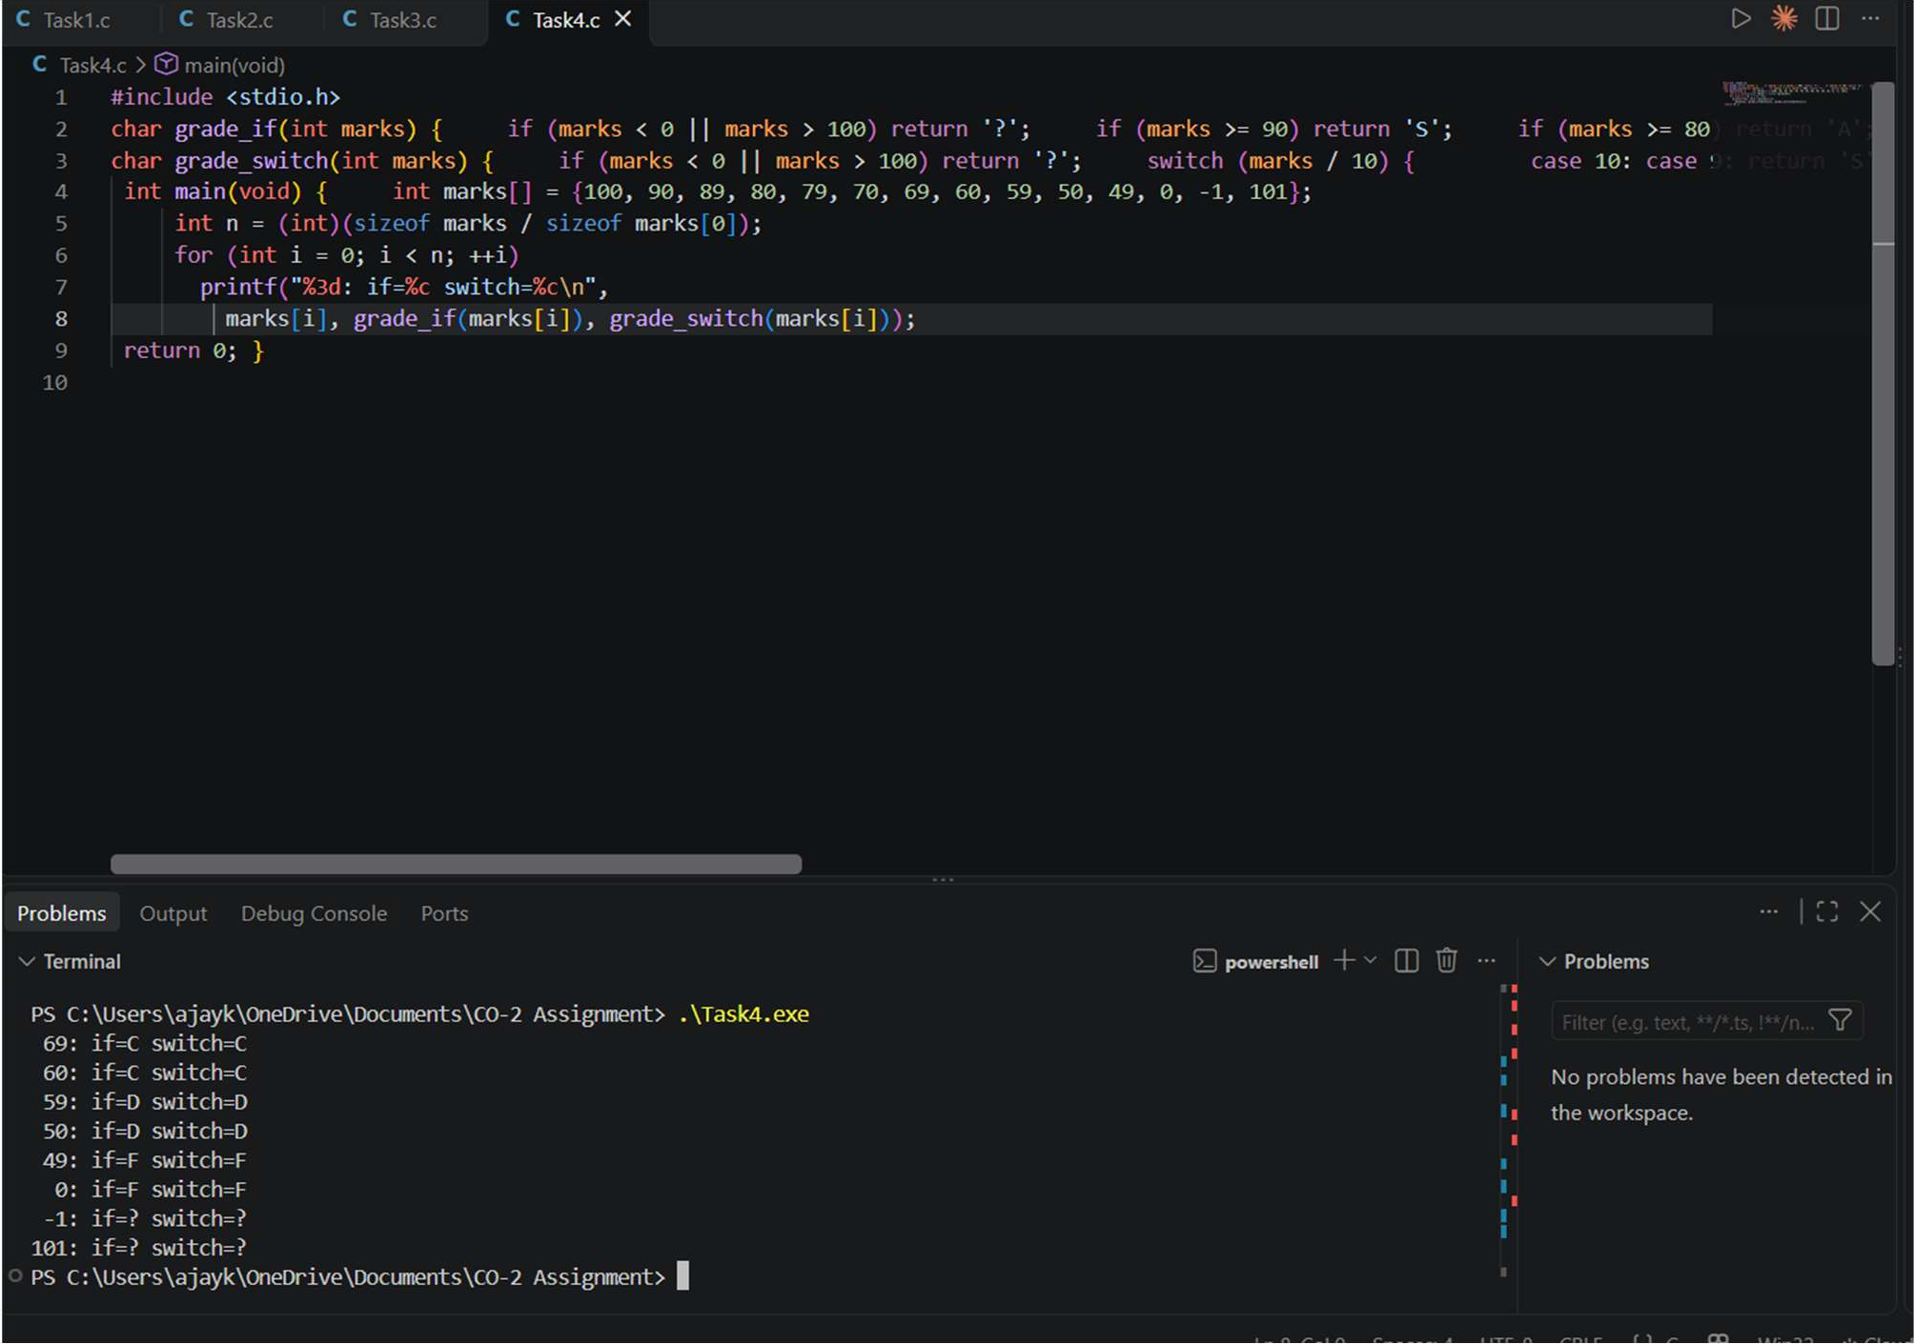

Analysis / Discussion
Both versions should produce the same grade for all valid inputs. The required checks include 100:S, 90:S, 89:A, 80:A, 79:B, 70:B, 69:C, 60:C, 59:D, 50:D, 49:F, 0:F, and -1/101: invalid. The switch version must validate the range before dividing by 10; otherwise negative and over-100 inputs may be incorrectly classified. If a `break` is removed from a switch case that does not return, execution falls through into later cases and can produce an incorrect result. A switch cannot directly check 75–84 because case labels must be constant integral values, not ranges. The else-if ladder is easiest to maintain when boundaries change. For scholarship eligibility, nested if statements or a lookup table can combine grade with income bands; a switch alone cannot express both range-based conditions cleanly.

Alternative Concept and Complexity Analysis
The lookup table described in the question can classify valid marks in O(1) time using marks / 10 as an index, with O(11) extra storage. The ladder performs up to a fixed number of comparisons, also O(1) for this small set. The ladder is more readable for changing ranges; a table is compact when boundaries are fixed and carefully validated.

Result
Both implementations classify the supplied boundaries correctly when input validation and switch breaks are used. An else-if ladder is recommended for grade ranges, with nested if statements for scholarship conditions.

TASK 5 — Count the Work Done by a Loop — Prime Ticket Verification (7 Marks)
Bloom's Level: K4 – Analyse

Task / Problem Statement
A college fest awards prizes to ticket numbers that are prime. The initial method tests every divisor from 2 to n-1, which performs unnecessary work for large ticket numbers.

Aim
To improve prime checking using the square-root property, compare for, while and do-while loops, and count the number of divisions.

Concept / Theory
If n has a divisor greater than its square root, it must also have a divisor smaller than its square root. Therefore it is sufficient to test divisors while i*i <= n. The expression `i <= n / i` avoids possible overflow from `i * i`. A do-while loop executes at least once, so small values such as 2 and 3 need special handling.

Procedure / Algorithm
- If n is less than 2, report not prime.
- Try divisors starting at 2.
- Stop when i is greater than n / i or when a divisor is found.
- Increase the division counter for each modulo test.
- Compare the original n-1 method with improved for, while and do-while versions.

Program / Source Code
#include <stdio.h> unsigned long checks; int
prime_original(unsigned long n) {
checks = 0; if (n < 2) return 0; for (unsigned long i = 2; i < n; ++i) {
++checks; if (n % i == 0) return 0;
} return 1; }
int prime_for(unsigned long n)
{
checks = 0; if (n < 2) return 0;
for (unsigned long i = 2; i <= n / i; ++i) {
++checks; if (n % i == 0) return 0;
} return 1; }
int prime_while(unsigned long n)
{ unsigned long i = 2; checks = 0; if (n < 2) return 0; while (i <= n / i) {
++checks; if (n % i == 0)
return 0; ++i; } return 1; }
int prime_do(unsigned long n)
{ unsigned long i = 2; checks = 0; if (n < 2) return 0; do { if (i > n / i) break;
++checks;
if (n % i == 0) return 0; ++i; } while (i <= n / i); return 1; } int main(void) { unsigned long values[] = {97, 100, 7919, 1000003}; for (int k = 0; k < 4; ++k) { int result =
prime_for(values[k]); printf("%lu %s divisions
= %lu\n", values[k], result ? "prime" : "not prime", checks); } return 0; }

Output:

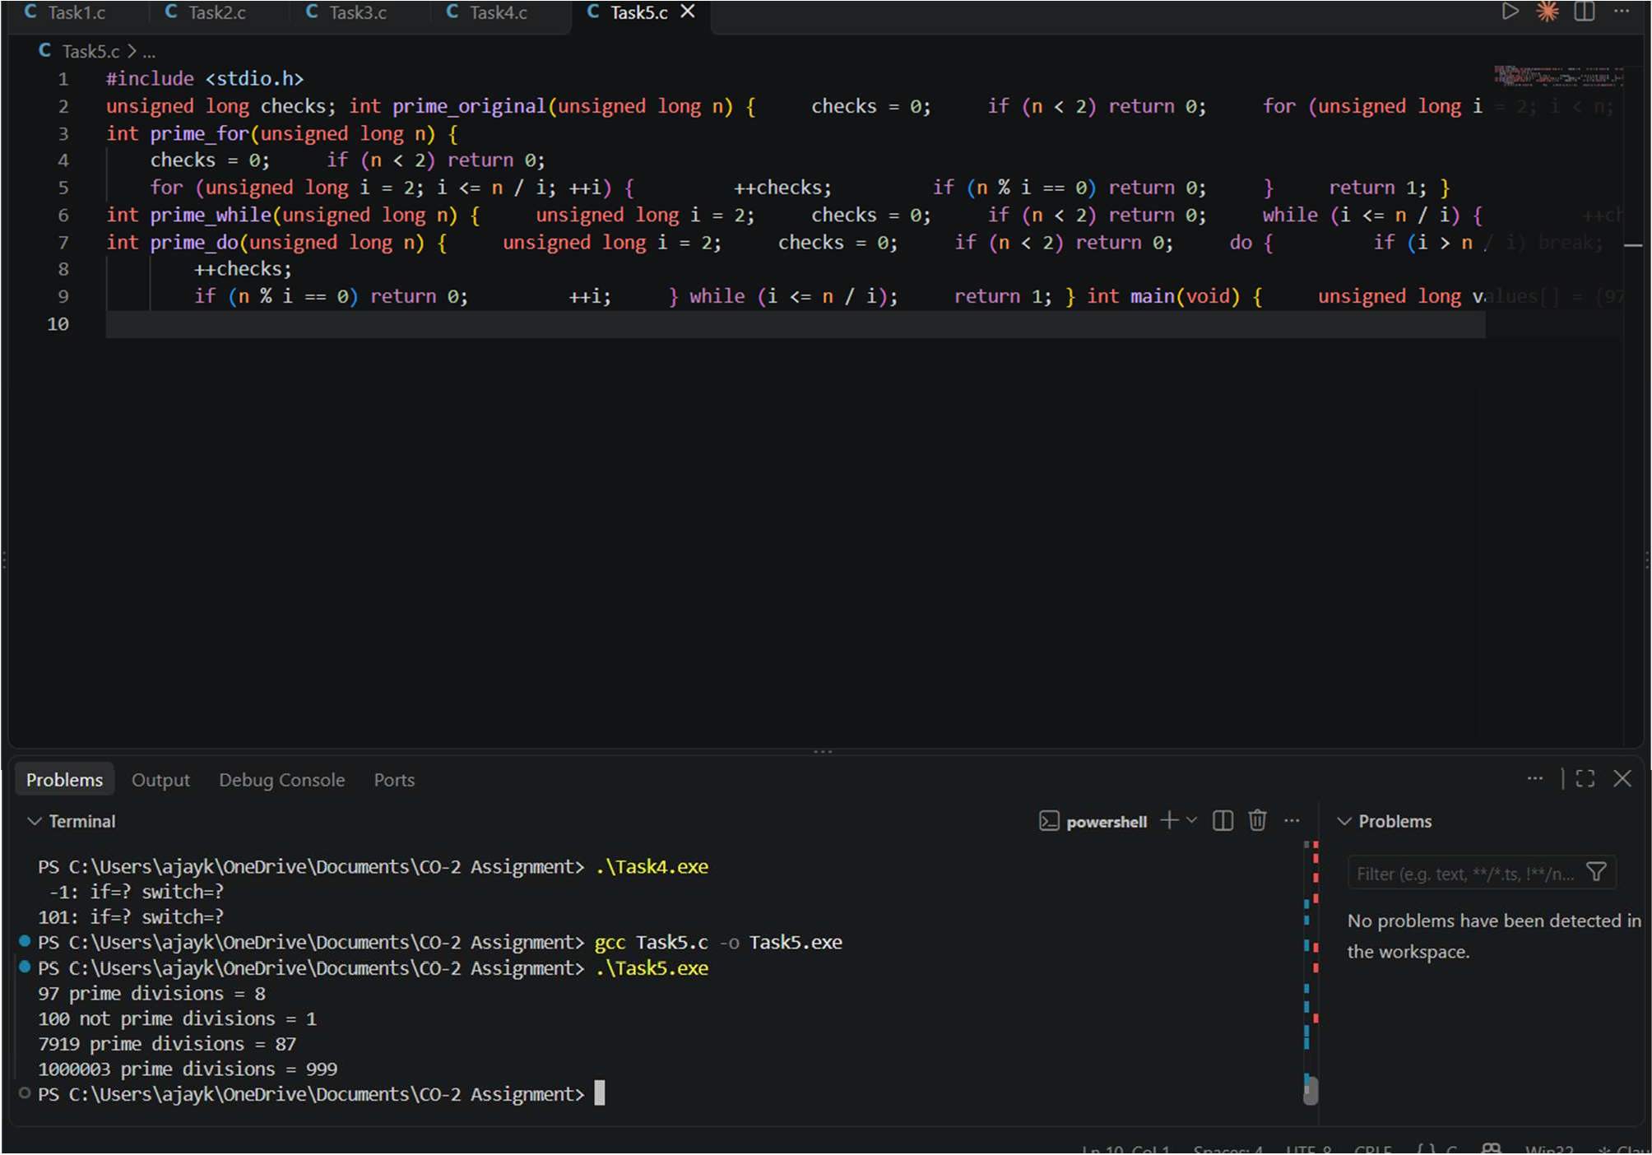

Analysis / Discussion
The improved loop tests only possible divisors up to the square root. For the supplied values, the expected improved counts are 8 for 97, 1 for 100 (divisor 2 is found immediately), 87 for 7919, and 999 for 1,000,003. The original loop can perform up to n-2 divisions for a prime number, while the improved loop performs at most about √n divisions. The for and while versions have the same work. The do-while version must check its stopping condition before performing a modulo operation; this avoids an unnecessary test for n=2 and n=3. Using `i * i <= n` can overflow for very large unsigned values; `i <= n / i` avoids that multiplication overflow. Changing the improved condition to `i < n` would again perform many unnecessary checks.

Alternative Concept and Complexity Analysis
If many numbers up to N must be checked, the Sieve of Eratosthenes can mark primes once in O(N log log N) time and O(N) space, then answer each query in O(1). For only a few ticket numbers, trial division uses much less memory and is simpler. The choice depends on how many queries are expected.

Result
The square-root method greatly reduces trial divisions for large prime tickets. For one or a few inputs, the improved trial-division loop is suitable; for many queries up to a fixed maximum, a sieve may be better.

TASK 6 — Loops That Must Terminate — Loan Repayment Schedule (8 Marks)
Bloom's Level: K5 – Evaluate

Task / Problem Statement
A self-help group lends money at a monthly interest rate. Interest is added to the outstanding balance every month and a fixed repayment is made. The program must print the schedule until the loan is repaid and report months and total interest.

Aim
To select a suitable loop, calculate monthly interest and repayment safely, handle the final partial repayment, and prevent a non-terminating schedule.

Concept / Theory
A while loop is suitable because the number of months is not known in advance. Money should be represented in integer paise to avoid floating-point equality problems. If repayment is less than or equal to the monthly interest, the balance will not decrease and the loan cannot be repaid under the chosen fixed-payment rule.

Procedure / Algorithm
- Read principal, monthly interest rate and fixed repayment.
- Validate that principal and repayment are positive and rate is non-negative.
- Each month calculate interest and add it to the balance.
- If repayment is not greater than the interest, stop and report that the loan will not amortise.
- Pay the smaller of fixed repayment and remaining balance; accumulate interest and stop at zero or at the safety limit.

Program / Source Code
#include <stdio.h>

int main(void) { long long balance, repayment, total_interest = 0; double rate_percent; int month = 0, limit = 360;

printf("Principal in paise: ");
if (scanf("%lld", &balance) != 1 || balance <= 0) return 1; printf("Monthly interest rate (percent): "); if (scanf("%lf", &rate_percent) != 1 ||
rate_percent < 0.0 || rate_percent > 100.0) return 1; printf("Fixed monthly repayment in paise: ");
if (scanf("%lld", &repayment) != 1 || repayment <= 0) return 1;

while (balance > 0 && month < limit) { long long interest = (long long)(balance * (rate_percent / 100.0) + 0.5); long long due = balance + interest; long long paid;

if (repayment <= interest) { printf("Repayment is not greater than monthly interest.\n"); return 1; }

paid = repayment < due ? repayment : due; balance = due - paid; total_interest += interest; ++month;

printf("Month %d: interest=%lld paise, paid=%lld paise, " "balance=%lld paise\n", month, interest, paid, balance); }

if (balance == 0) { printf("Loan repaid in %d months.\n", month); printf("Total interest: %lld paise\n", total_interest); } else { printf("Safety limit reached; remaining balance=%lld paise\n", balance); } return 0; }

Output:

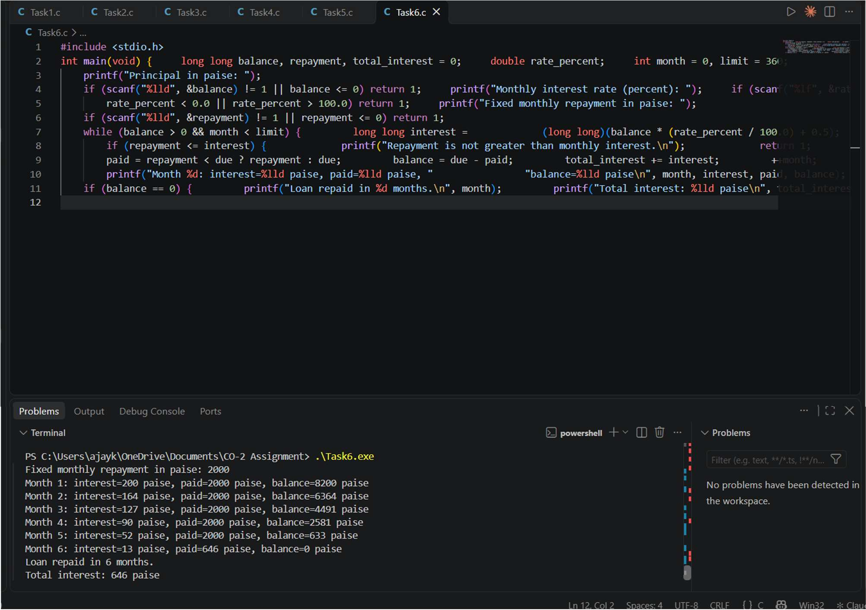

Analysis / Discussion
For the hand-check example, principal Rs 10,000, monthly interest 2%, and repayment Rs 2,000: month 1 interest Rs 200, due Rs 10,200, paid Rs 2,000, balance Rs 8,200; month 2 interest Rs 164, due Rs 8,364, paid Rs 2,000, balance
Rs 6,364; month 3 interest Rs 127.28, due Rs 6,491.28, paid Rs 2,000, balance Rs 4,491.28. The same method
continues, with the final payment limited to the amount due. The program above accepts paise and rounds monthly interest to the nearest paise. The exact schedule depends on this rounding rule. `balance != 0` is unsafe with floating-point values because repeated calculations may leave a tiny residual. A fixed repayment not greater than monthly interest cannot reduce the balance. The 360-month limit prevents an endless run.

Alternative Concept and Complexity Analysis
The formula in the question can estimate the number of payments in O(1) time, but it assumes a fixed rate and payment and can be affected by rounding. Simulating each month takes O(m) time for m months and O(1) extra space, while providing a complete month-by-month schedule. The loop is preferable when the schedule itself is required.

Result
The while loop models the repayment schedule and terminates when the balance reaches zero, repayment cannot reduce the loan, or the safety limit is reached.

